**Discussion Question: 100 Things**

Using the ***100 Things Every Designer Should Know About People*** reading assignment, select two (2) of the "things" you read about, include the number and title of the "thing" (i.e. #36 Time is Relative) , and then do two embellishments, one embellishment and one visual example, or two visual examples.

1. **Embellish:** Tell us something that the reading did not tell us on that specific "thing" or embellish on what was presented. Be sure you are adding meaningful content to the conversation and not just making noise. Your addition can be a link to an article or you can write out your embellishment.
2. **Visual Example:** Provide us with a graphic example that is relevant to web design. This can be something you create or something you find. Again, be sure to add meaningful content to the conversation.

For my first focus of this discussion board, I will be embellishing on Topic 29: Minds Wander 30 Percent of the Time. We may have the best intentions when sitting down to work on something, but that does not mean our focus is where it should be. Our first reaction to mind wandering may be that it is a complete waste of time. Of course, it can be annoying to feel a lack of focus, but sometimes, there is a reason our mind wanders onto other ideas.

A big distraction can be our devices since roaming off onto other sites or applications is easier than working on the designated task. An application that can help limit distractions is ScreenZen. By using this application, you can limit how many times you are allowed to open an app in a day. It pops up a message, similar to the one in the photo, to ask if this is important at the moment. If you click unlock, it will take 5 seconds or more, depending on the setting, before opening up. This is a good way to remind yourself of the true task and help when the mind wanders. A screenshot of a video chat

The second topic I am embellishing is Topic #33: People Process Information Best in Story Form. Our text discusses the importance of a good story and how it has the power to capture readers’ attention. Aside from verbal and written storytelling is visual storytelling. Stories are powerful and can help ingrain information into a person’s mind. Movies, television shows, advertisements, artwork, music, and even web design can tell a story.

Color stories are told based on the array of colors utilized in UI. It focuses on cohesion and can wrap everything nicely together. It helps fit a brand’s aesthetic. Here is an example by Digital Synopsis of a color pattern that can be used for a design.

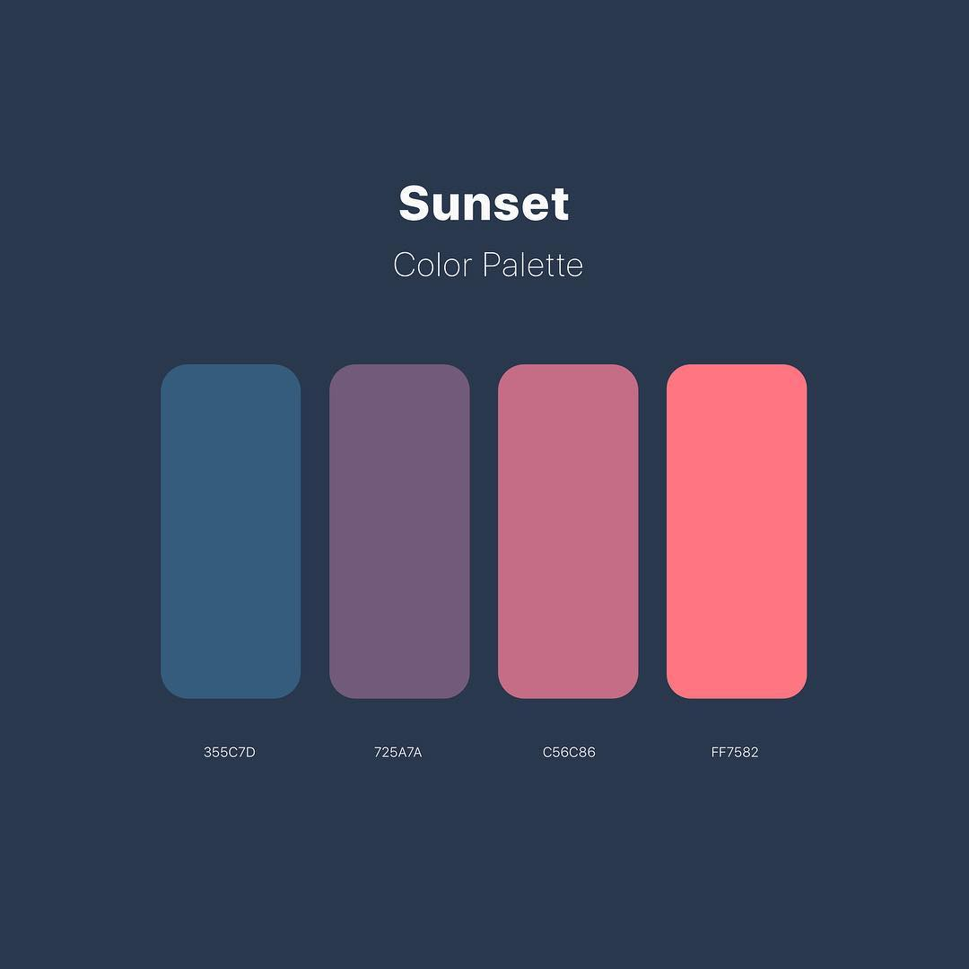

***Before you submit your thread, put your name in the subject line.***

**Assignment Requirements and Grading:**

1. An initial post of approximately 250 words is due by **Thursday, 11:59 p.m., CST**.
2. For the initial post to be considered substantive, it should be at least 250 words in length and fully cover the topics being presented. Single-sentence definitions or responses will not be awarded points.
3. Submit your post by clicking on the **Assignment Link** above, then **Create Thread**. You must create a thread in order to view your peers' posts. Tip: Create your post in a Word document and then copy and paste your work into the thread.
4. A minimum of three (3) responses, **to the original threads of other students**, of 100-200 words each are due by **Sunday, 11:59 p.m., CST**.
5. To view the rubric grading criteria, click on the following link: [Discussion Board Grading Rubric](https://content.bellevue.edu/cst/csd/rubricdbv3.pdf).

**(50 points)**

Arely, you did a fantastic job of embellishing topics 29 and 34. I liked reading more about the connection with evolution since I think it is an interesting point. Before reading this section of the book, I would have fallen into the camp of thinking mind wandering is completely bad, but I now understand how helpful it can be. I like how you mentioned balancing mind wandering is a valuable skill, and I think you are right. I think topic 34 explains part of the reason why we have embellishments for our textbook each week. Seeing visible examples helps people remember and learn.

Brett, your post for this discussion was remarkably insightful, and it was intriguing to hear how this has touched you in your personal life. I also chose to embellish the same two topics, so I enjoyed reading how you embellished them in ways other than mine. It was reassuring knowing that it may seem like a downfall to some, but it can be a superpower! It is truly about working with what we have and learning how to make our minds the most productive, even in moments that feel like the antithesis of that. Whether we realize it or not, many mediums are created to tell a story.

Jessica, you did a nice job on your post for this module. You are spot on when you say stories are powerful. They indeed are and have the power to change someone’s perspective on life. A story can move someone in an array of ways. It is about making the stories memorable by making a connection. I also agree with you that humans naturally categorize information. Even if something does not match a category, it might not be surprising to see some things mentioned within it. Genres for books, movies, and television can sound simple to categorize but bring much more nuance than we might realize.